Course _______Specialist______ Year __12_____

Student name: ________________ Teacher name: ________________

Date: 21 Aug Fri

Task type: Response

Time allowed for this task: _____45______ mins

Number of questions: _____6______

Materials required: NO CLASSPADS/CALS

Standard items: Pens (blue/black preferred), pencils (including coloured), sharpener, correction fluid/tape, eraser, ruler, highlighters

Special items: Drawing instruments, templates, , and up to three calculators approved for use in the WACE examinations
NO NOTES ALLOWED

Marks available: __39____ marks

Task weighting: _12___%

Formula sheet provided: Yes

Note: All part questions worth more than 2 marks require working to obtain full marks.

Q1 (4.1.2) (3, 3 & 3 = 9 marks)

Determine the following integrals showing full working.

Q2 (4.1.1 -4.1.3) (3, 3 & 3 = 9 marks)
Determine the following definite integrals showing full working.

Q3 (4 marks)
Determine the following integral showing full working.

Q4 (4.1.5-4.1.6) (5 marks)
Consider a cylindrical drill of width 2 cm that carves a cavity inside a solid sphere of radius 5 cm as shown below. Determine the volume of the sphere remaining.(Simplify)

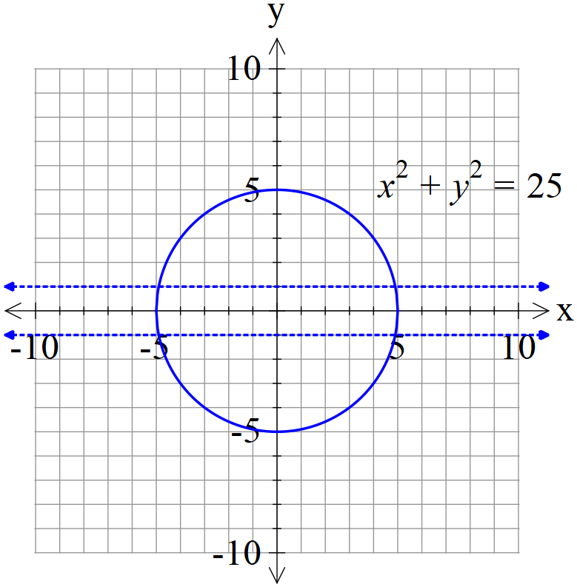

Q5 (4.2.4) (4 marks)
Determine the solution to the following differential equation given that (1,1) is a known point.(No need to simplify)

Q6 (4.2.6) (1, 5 & 2 = 8 marks)
Consider the differential equation with positive constants.
- Determine the limiting value for as

- Show how to derive using integration and partial fractions that the general solution is

- Consider with an initial value of . Determine when t=50.
(No need to simplify)

.

